**Downloading and Installing Snort**

Goto [www.snort.org/snort-downloads](http://www.snort.org/snort-downloads)

Download the latest Snort .exe file

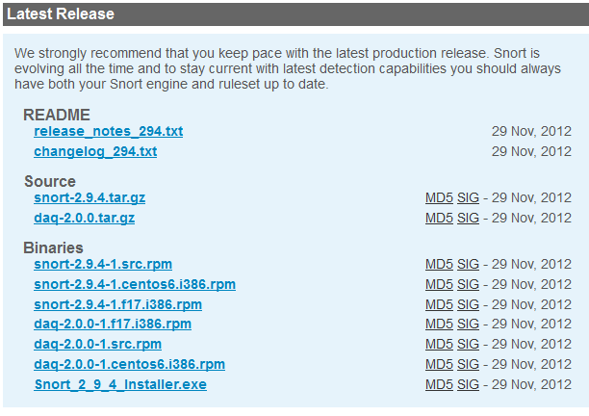

Open the Snort .exe file and follow the installation instructions. Install snort into the C:\ directory.

**Downloading the rules**

Goto [www.snort.org/snort-rules](http://www.snort.org/snort-rules)

Under Registered User Release, download the same version number file as the .exe file. (Need to first register to download rules).

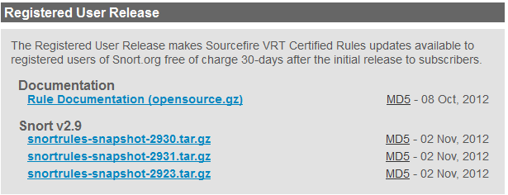

Once the rules is downloaded, extract the file and copy and overwrite the \rules directory into C:\Snort\

The next step is to download and install WinPcap for windows, which is needed for snort.

**Downloading WinPcap**

Goto <http://www.winpcap.org/install/default.htm> and download the latest WinPcap for Windows.

Open the downloaded WinPcap file and follow the installation instructions.

**Configuring Snort**

Once Snort and WinPcap is downloaded, copy the snort.conf file from the Installation Instructions folder from the CD into C:\Snort\etc.

Next copy the scan.rules file from the Installation Instructions folder from the CD into C:\Snort\rules

Move the two .log files (newdat3.log and slog2.log)from the scan and into C:\Snort\log\ directory

**To run snort, make sure you are in C:\Snort\bin** directory

Open command prompt and run the following line to test:

snort -r C:\Snort\log\newdat3.log -c C:\Snort\etc\snort.conf -l C:\Snort\log -A console > C:\Snort\log\newdatXX.txt

Or copy the “runLogging.bat” file onto the desktop and run the file “runLogging.bat” located on the CD.